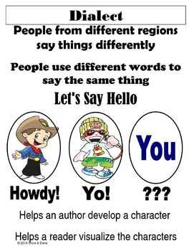

Examples that the Hintz family thought of:
soda / pop / coke rubberband / gumband
year 5 / grade 5 mam / miss
pa / dad / father ma / mom / mother
pants / trousers ya all / everyone / you guys
outhouse / long drop
bathroom / restroom / head / toilet / WC (water closet) / privy hood / bonnet of car use it / go potty
Can you think of more?

