|  |
| --- |
| Essential/Focus Questions |

1. How do readers pay attention to details that help them build important ideas about their stories?
2. In what ways can readers read historical fiction texts through various lenses?
3. How can readers support each other and be open to new ideas in book club conversations?

|  |
| --- |
| Lesson Sequence |

1. Noting details about the setting. Students pay attention to details in historical fiction texts that show what the setting looks like and feels like.
2. Supporting each other in book discussions. Student*s*make sure that each member feels like a part of the group in a book clubs and that each member always feels supported by the group.
3. Keeping track of story elements. Students pay attention to the story elements as they read, continually building their understanding of what is happening.
4. Noticing shifts in time. Students notice when time jumps back and forth and create story timelines to keep track of events.
5. Keeping track of historical events. Students keep track of historical events and create historical timelines to stand alongside their story timelines.
6. Understanding characters. Students understand that characters in historical fiction stories are shaped by the times in which they live.
7. Reading descriptive passages. Students pay close attention to descriptive passages to deepen their understanding of the story.
8. Pausing at important passages. Students pause and read important passages attentively to grow ideas about their stories.
9. Finding significance in small details. Students learn how small details in a story can help them build important ideas.
10. Carrying important ideas forward. Students keep important ideas in mind, allowing them to shape their thinking as they read.
11. Creating claims. Students turn their important ideas into claims and use them as a lens through which they can read other stories.
12. Listening carefully. Students learn that it is important to be open to new ideas as they read and as they listen to ideas from others.
13. Reading through other perspectives. Students learn how to experience a story through the perspective of secondary characters.
14. Reading through the lens of power. Students deepen their thinking by reading through the lens of power. They ask, "Who has the power in this story?"
15. Reading relevant nonfiction texts. Readers learn how to collect and read relevant nonfiction texts alongside their historical fiction novels.
16. Applying themes across other texts and to real life. Students learn that similar themes apply across many texts and to real life situations.
17. Noticing the critical choices. Students pay close attention to the critical choices that characters make in historical fiction stories.
18. Reflecting on reading. Students reflect on their reading and learning to help them live their lives differently.

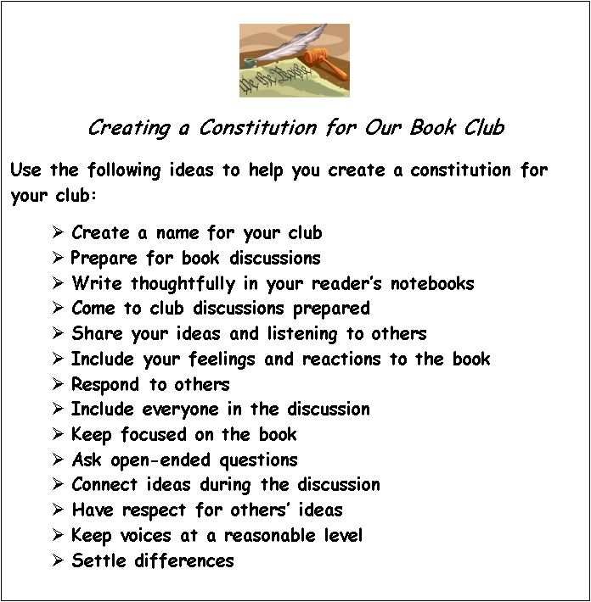

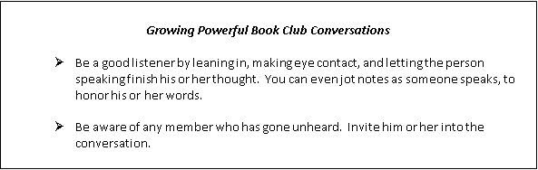

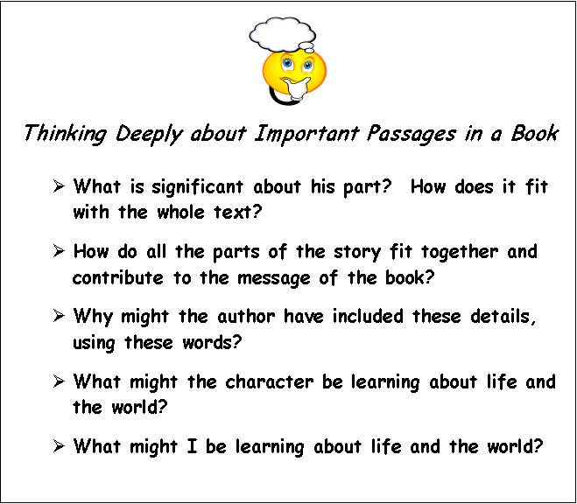

***MC900440428[1]***

***Thought Prompts for Generating Quick Writes***

* **I used to think …,**

**But now I realize …**

* **When I first read this, I thought …,**

**But now, rereading it, I realize …**

* **On the surface, this is the story of …**

**But when you look deeper, it’s really about …**

* **Some people think this is a story about …**

**But I think it is really a story about …**

* **My ideas about … are complicated.**

**In a way I think …,**

**But on the other hand, I also think …**

