How Clutter Affects Your Brain (and What You Can Do About It)
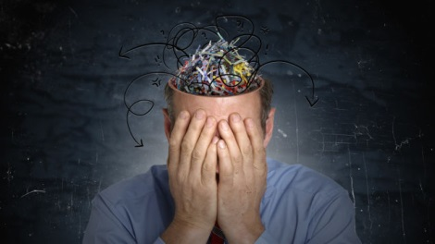
A few years ago, I worked at a web design agency as a product manager. The part of the job I loved the most was working on product with our design team and clients. Unfortunately, this was only about 10 percent of the work that I actually got to do. The majority of the time, I was trying to control the constant flow of stuff–keeping track of meeting notes, searching for files, and trying to stay up-to-date with the latest technology news.
I was mentally exhausted. I’d get home feeling that I hadn’t really accomplished anything. Once I left the agency and started ooomf, I wanted to fix how I approached consumption in my life. Over the last few years, I’ve discovered ways to reduce the noise of stuff around me so I can focus on creation and have more time for the things that matter most. The last year has been the most productive of my life and I owe a lot of it to understanding the importance of decreasing how much I consume and coming up with ways to cut clutter.

How Clutter Happens
You collect things for a number of reasons–maybe you think you’ll need to use it later, it has sentimental value, or you spent good money on it so you feel you need to keep the item, even if you haven’t touched or used it in weeks, months, or years. You might be holding on to that book you bought a year ago that you swear you’ll read or those killer pair of shoes that you’ll bring out for just the right occasion.
But the reality is, you probably made a mistake in buying those things and it literally hurts your brain to come to terms with that fact. Researchers at Yale recently identified that two areas in your brain associated with pain, the anterior cingulate cortex and insula, light up in response to letting go of items you own and feel a connection towards:
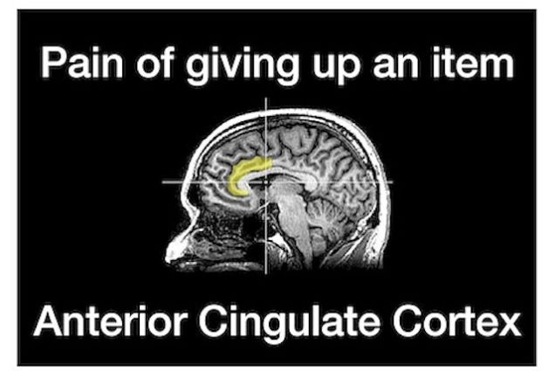
This is the same area of the brain that lights up when you feel physical pain from a paper cut or drinking coffee that’s too hot. Your brain views the loss of one of your valued possessions as the same as something that causes you physical pain. And the more you’ve commited emotionally or financially to an item, the more you want to keep it around.

Why Apple Wants You to Touch Their Stuff
When it comes to physical things, merely touching an item can cause you to become more emotionally attached to it. In this study, researchers gave participants coffee mugs to touch and examine prior to participating in an auction. The researchers varied the amount of time the participants were able to handle the mugs to see if this would have an effect on the amount of money participants would be willing to spend on the mugs during the auction.
The results of the study showed that participants who held the mugs longer, were willing to pay over 60 percent more for the mugs than participants who hed the mugs for shorter periods. The study concluded, the longer you touch an object, the greater the value you assign to it.
Apple is familiar with the effect of touch on your psychology and has brilliantly designed its retail stores to help you build an emotional attachment to their products. Here’s a shot of an Apple Store:
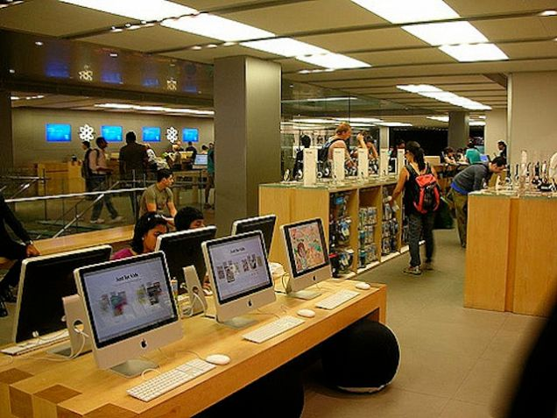
Author Carmine Gallo is writing a book about the ins and outs of the Apple Store. Galloexplains that everything in the Apple Store is designed for you to touch and play with, to make you feel like it’s your own. Gallo states:
The main reason notebook computers screens are slightly angled is to encourage customers to adjust the screen to their ideal viewing angle…The ownership experience is more important than a sale.
When you introduce new items into your life, you immedietely associate value with these items,making it harder for you to give them up in the future. This psychological connection to things is what leads to the accumulation of stuff.

Clutter’s Impact on Your Brain
Whether it be your closet or office desk, excess things in your surroundings can have a negative impact on your ability to focus and process information. That’s exactly what neuroscientists at Princeton University found when they looked at people’s task performance in an organized versus disorganized environment. The results of the study showed that physical clutter in your surroundings competes for your attention, resulting in decreased performance and increased stress.
A team of UCLA researchers recently observed 32 Los Angeles families and found that all of the mothers’ stress hormones spiked during the time they spent dealing with their belongings. Similar to what multitasking does to your brain, physical clutter overloads your senses, making you feel stressed, and impairs your ability to think creatively.

Clutter Isn’t Just Physical
Files on your computer, notifications from your Twitter and Facebook accounts, and anything that goes “ping” in the night competes for your attention. This creates a digital form of clutter that erodes your ability to focus and perform creative tasks. Mark Hurst, author of Bit Literacy, a New York Times best seller on controlling the flow of information in the digital age, put it best

