World Book Research Table
Topic | Picture | Fun Fact Copied | Fun Fact in My Own Words | Source (copy and paste here)
Alligator | 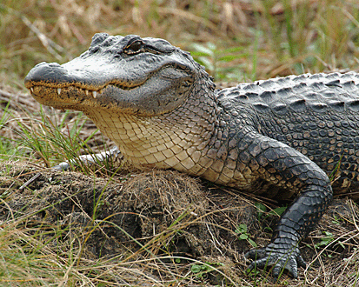
Ladybug | 